**Experiment 1:-**

**Aim:-**

TO CREATE A SIMPLE CLOUD SOFTWARE APPLICATION AND PROVIDE IT AS A SERVICE USING ANY CLOUD SERVICE PROVIDER TO DEMONSTRATE SOFTWARE AS A SERVICE (SAAS).

**Procedure:-**

1.goto zoho.com

2.login to the zoho.com

3.select one application.

4.enter application name.

5.Create new application.

6.select a template/create scratch of own.

7.drag the fields and drop .[if required change the field name.]

8.click on the DONE option.

9.software has been created.

**Implementation:-**

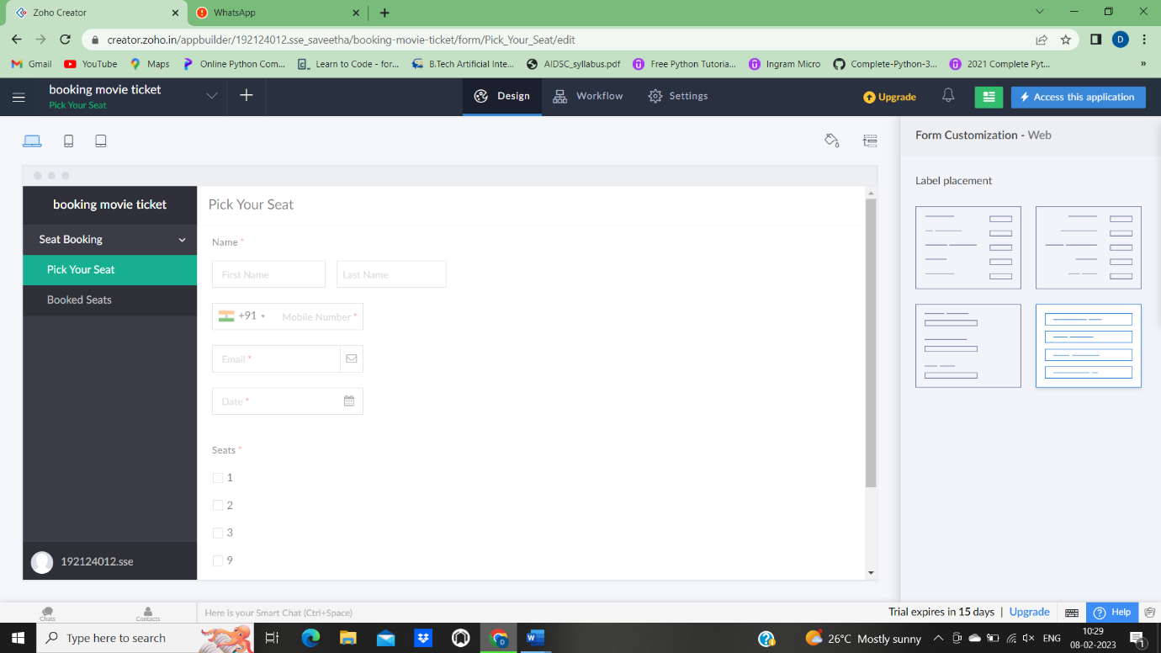

**Experiment 2:-**

**Aim:-**

To Create a simple cloud software application for Flight Reservation System using any Cloud Service Provider to demonstrate SaaS.

**Procedure:-**

1.goto zoho.com

2.login to the zoho.com

3.select one application.

4.enter application name.

5.Create new application.

6.select a template/create scratch of own.

7.drag the fields and drop .[if required change the field name.]

8.click on the DONE option.

9.software has been created.

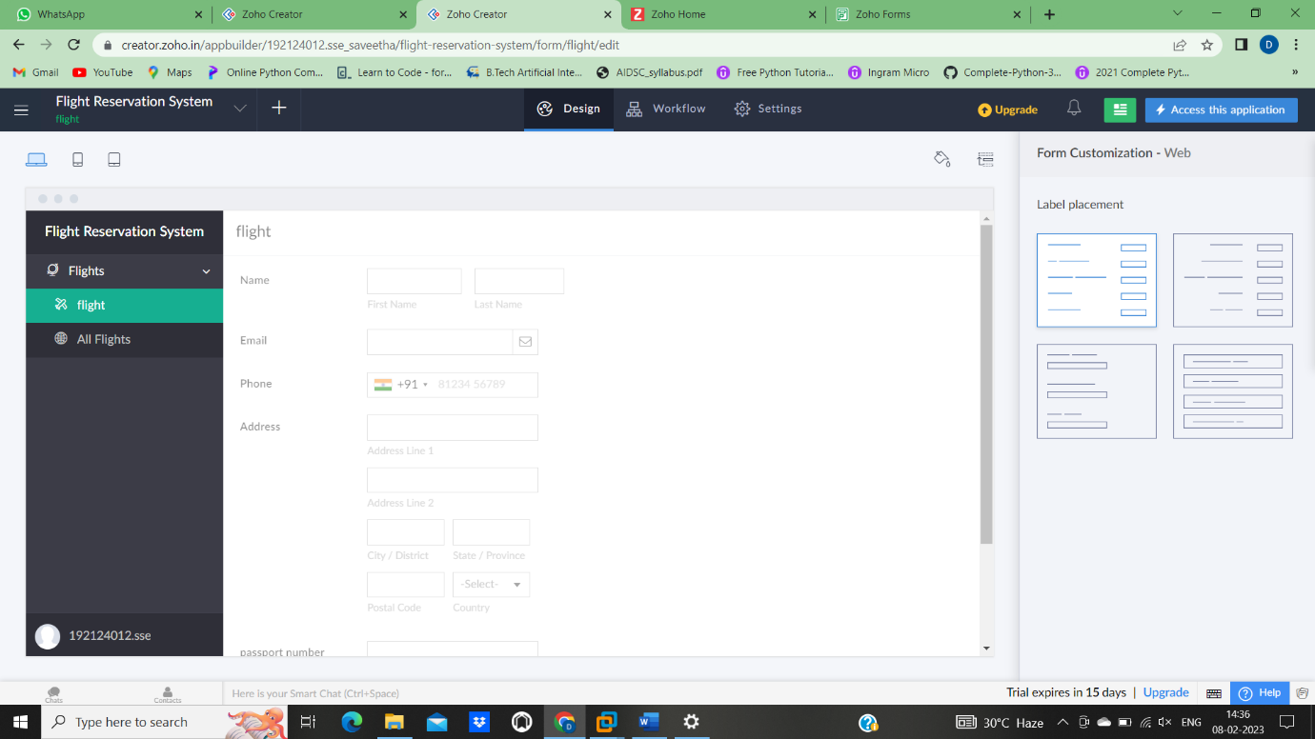

**EXPERIMENT 3**

**Aim:-**

To Create a simple cloud software application for Property Buying & Rental process (In Chennai city) using any Cloud Service Provider to demonstrate SaaS.

**Procedure:-**

1.goto zoho.com

2.login to the zoho.com

3.select one zoho form.

4.enter form name.

5.Create new form.

6.select a template/create scratch of own.

7.drag the fields and drop .[if required change the field name.]

8.click on the DONE option.

9.software has been created.

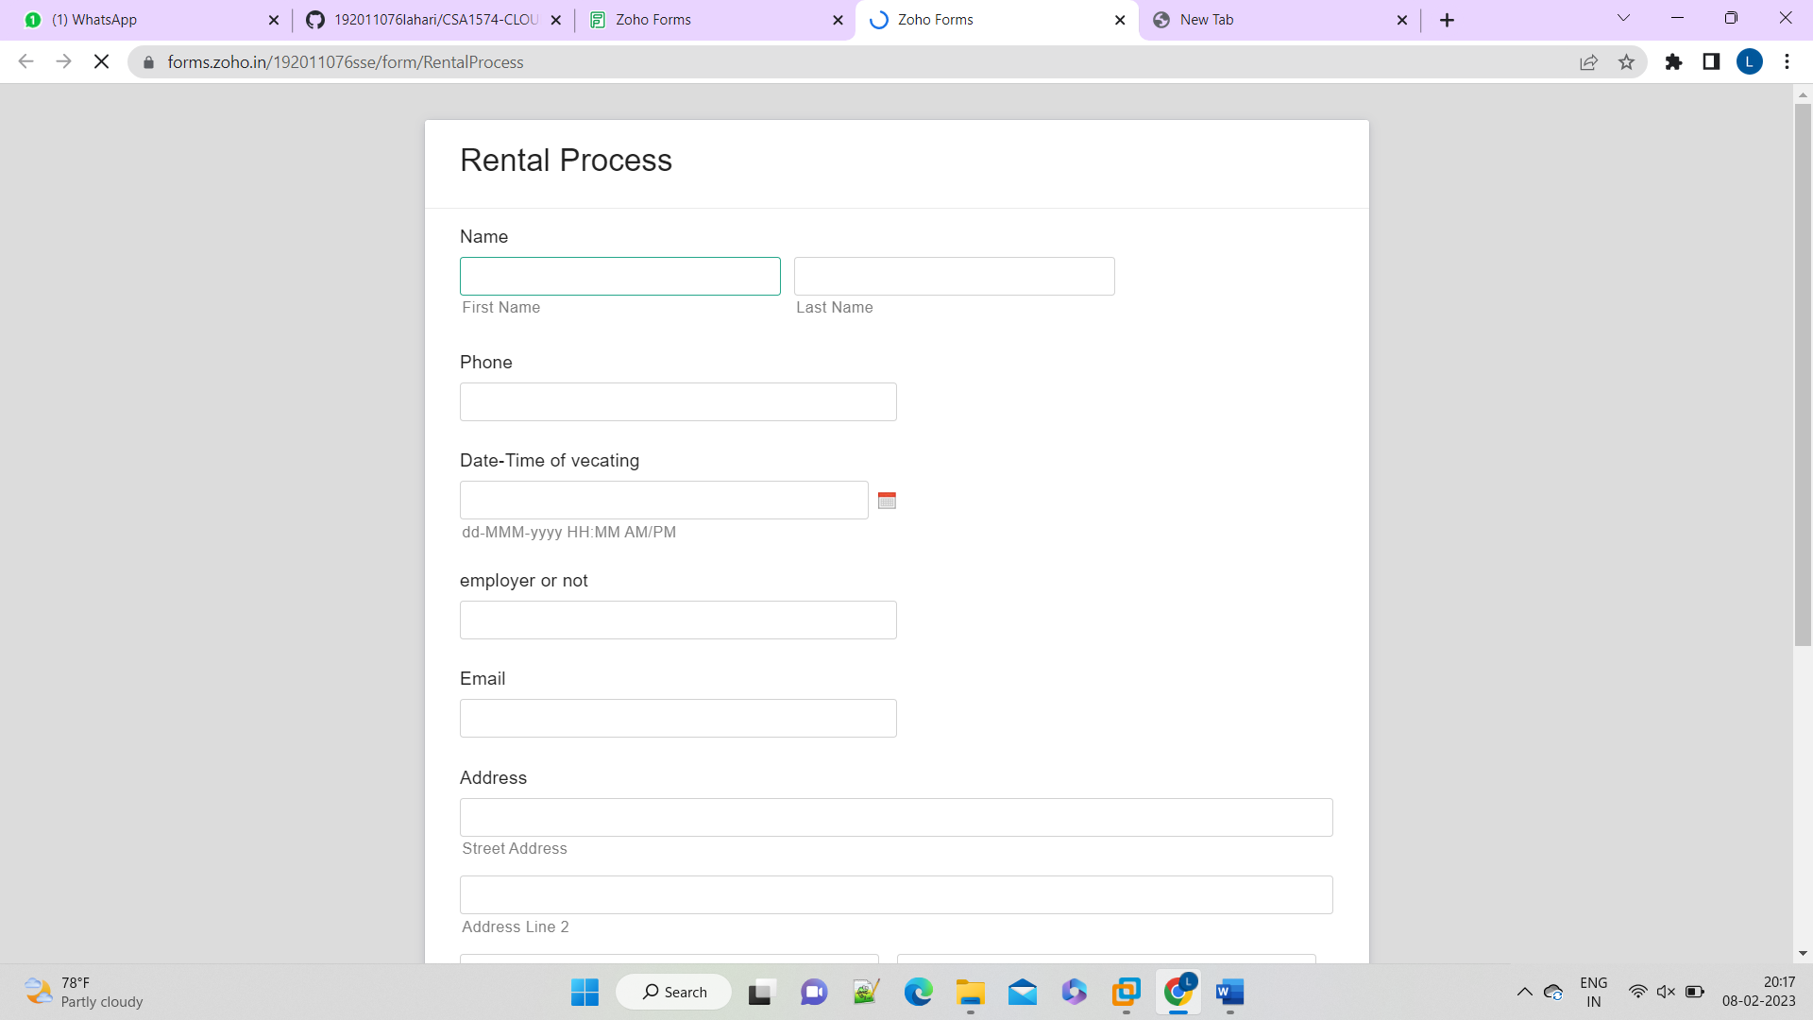

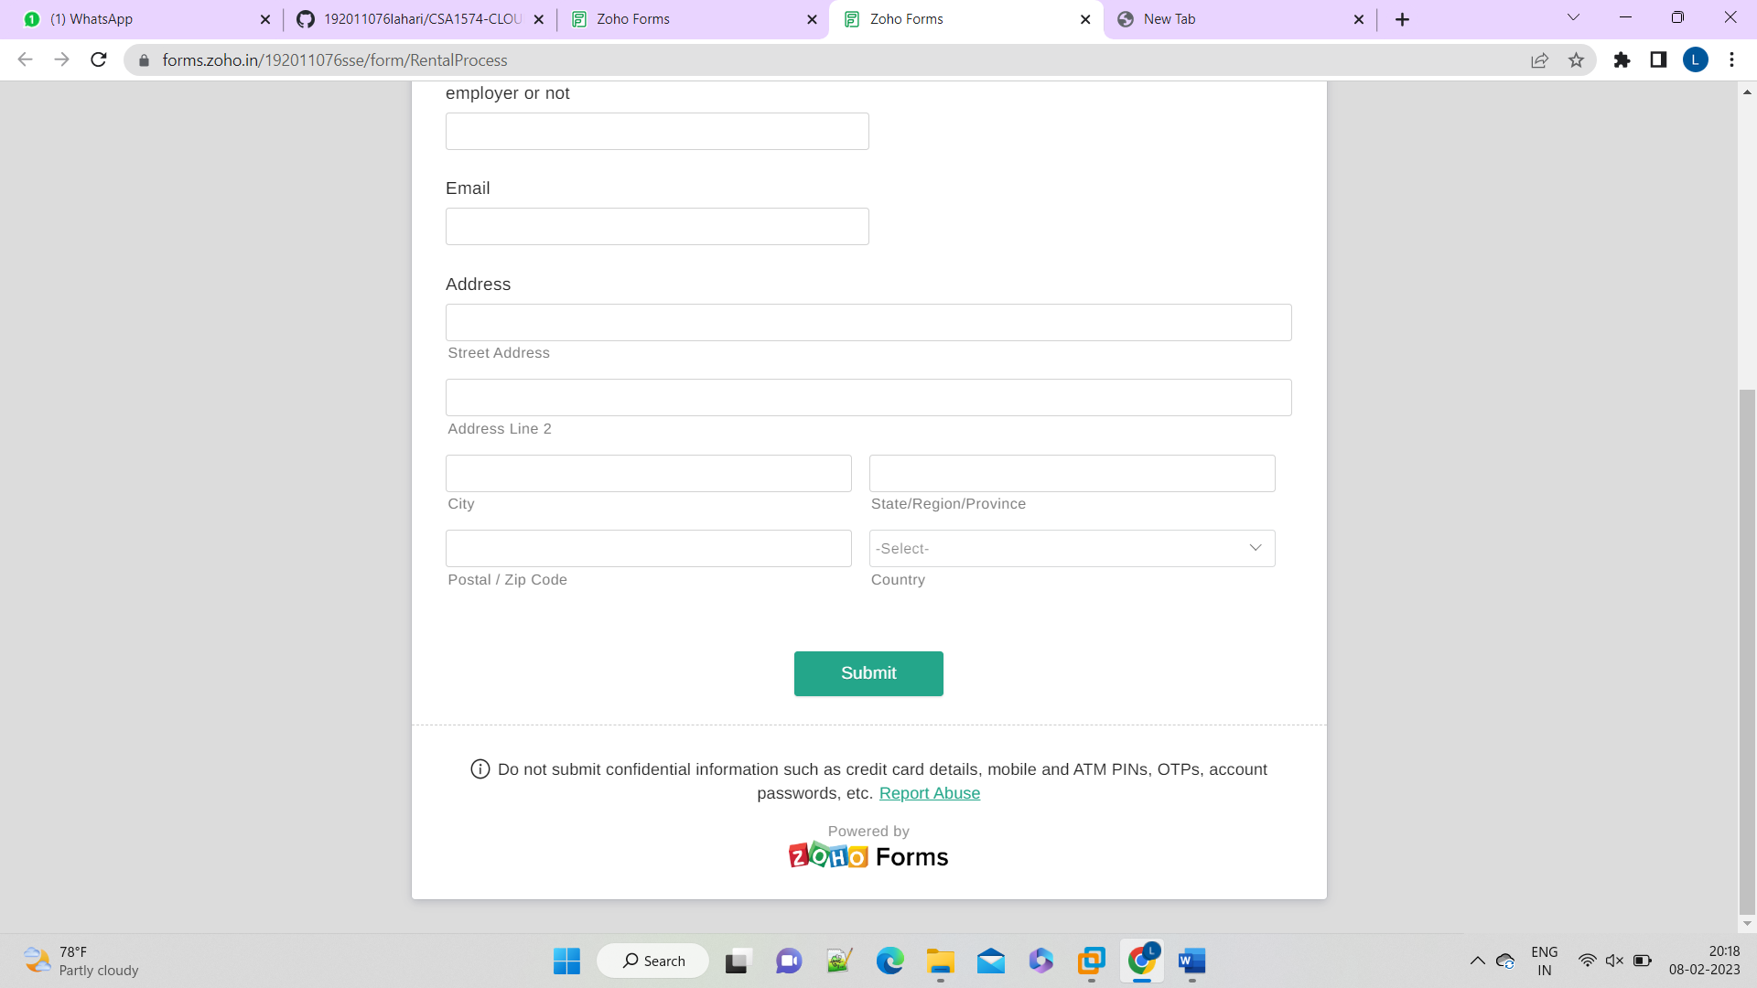

**EXPERIMENT 4**

**Aim:-**

Create a simple cloud software application for Car Booking Reservation System using any Cloud Service Provider to demonstrate SaaS.

**Procedure:-**

1.goto zoho.com

2.login to the zoho.com

3.select one application.

4.enter application name.

5.Create new application.

6.select a template/create scratch of own.

7.drag the fields and drop .[if required change the field name.]

8.click on the DONE option.

9.software has been created.

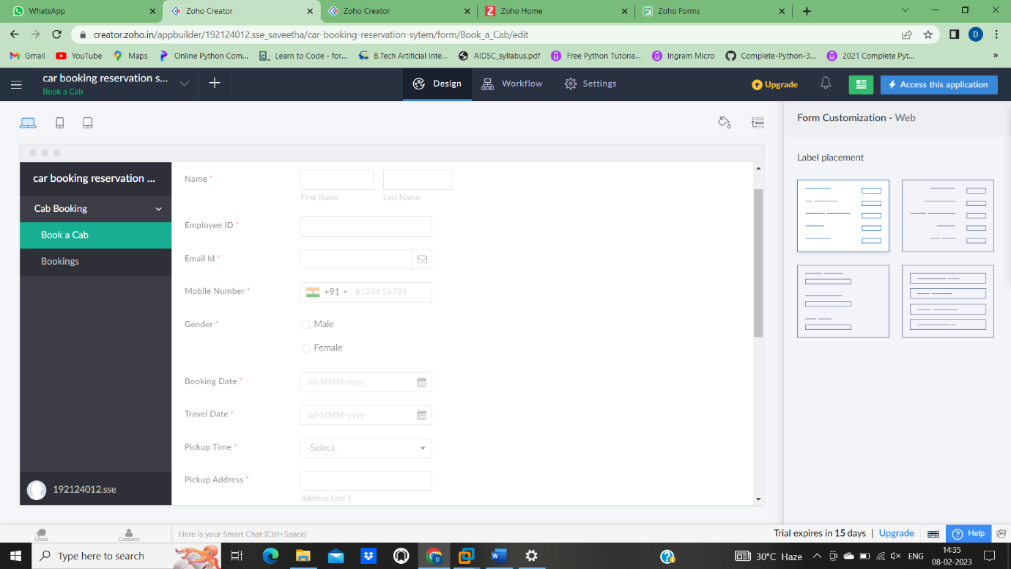

**Experiment 5:-**

**Aim:-**

To Create a simple cloud software application for Library book reservation system for SIMATS library using any Cloud Service Provider to demonstrate SaaS.

**Procedure:-**

1.goto zoho.com

2.login to the zoho.com

3.select one zoho form.

4.enter form name.

5.Create new form.

6.select a template/create scratch of own.

7.drag the fields and drop .[if required change the field name.]

8.click on the DONE option.

9.software has been created.

